

Mine It – Basic Proof-of-Work Simulation



**Objective/Aim:**  
  
 Simulate the PoW mining process by finding a nonce such that the SHA-256 hash of an input

(block header + data + nonce) begins with a chosen number of leading zeros (the difficulty).

**Apparatus/Software Used:**

* Laptop
* Word for documentation,
* PoW simulator (web-based)
* Internet (for access to the simulator and background reading)

**Theory/Concept:**

**What is Proof-of-Work?**

PoW requires significant computational effort to solve a deliberately expensive puzzle. The first miner to find a valid solution earns the right to append the next block and receive a reward..

**The Role of the Nonce**

A nonce (“number used once”) is varied by miners and combined with the block’s contents (e.g., previous hash, timestamp, data). The result is hashed; if the hash meets the difficulty target (e.g., starts with N zeros), the block is valid.

**Components of a Block in this Simulation**

* **Block Header:**Metadata
* **Data:** (payload to be stored)
* **Hash of the Previous Block:**
* **Nonce:** A number that miners change to solve the Proof-of-Work puzzle. It's a key component for finding a valid block hash.
* **Timestamp:** (block creation time)



**Procedure:**

|  |  |  |  |
| --- | --- | --- | --- |
|  |  |  |  |
|  |  |  |  |
|  |  |  |  |
|  |  |  |  |
|  |  |  |  |
|  |  |  |  |
|  |  |  |  |

**Step 1: there is a proof of work simulator where in realtime you can enter the data and mine a block**

**at: https://blockchain-academy.hs-mittweida.de/2021/05/proof-of-work-simulator/**

**Step 2:** there are blocks where you can give the input the data and mine it

**Step 3:** one by one give data and mine all the five block .

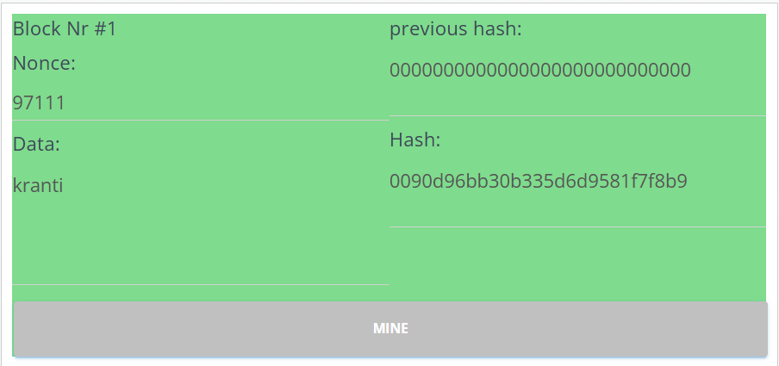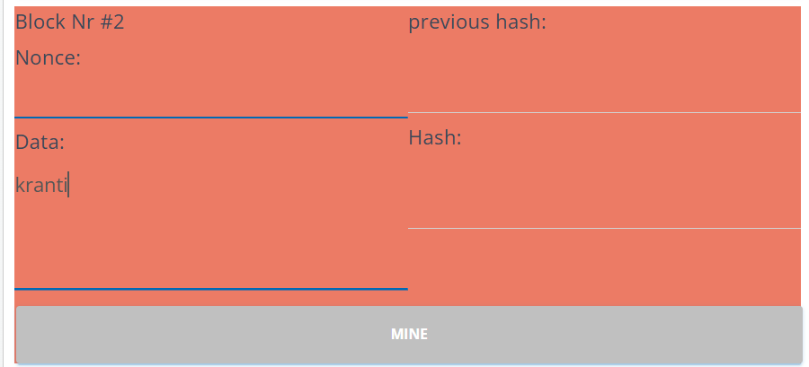

**Observation:**

* Determinism: The same input (header + data + nonce) always yields the

same SHA-256 hash.

* Avalanche effect: Changing even one character, digit, or space in the input drastically changes the hash.

